An Najah University – Faculty of engineering
Electrical Eng. Department
Instruments and Measurements

Instructor: Jamal Khrousheh 17/4/2010 2nd hr. exam

Question # 1 (5- marks)
A Maxwell bridge, designed to measure unknown impedance Ru , Lu of a coil is shown in figure below.
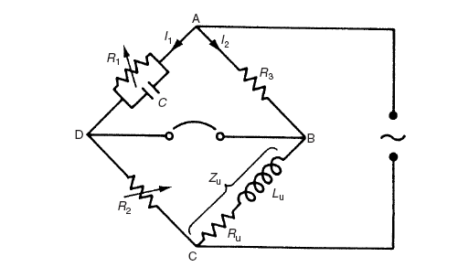
a- Derive an expression for Ru and Lu under balance conditions.
b- Calculate the Q factor for the coil if the supply frequency 50 Hz.

Question # 2 (10 marks)
What are the following bridges measured
a- Kelvin Bridge, Hay Bridge, Schering Bridge, Wien Bridge
b- What is the purpose of?
Intensity button, Focus button, Probe compensation, Attenuator
c- Draw block diagram for vertical stage for OSC. What is the main function of each stage?

Question # 3 (5 marks)
For the AC bridge shown, Knowing that R1= 100 ohm, C2= 100 uF , Lx= 100 mH, Rx= 200 ohm and wn = 1000 rad/sec, the bridge is unbalance, Where and what the is the value of a variable resistance to be added to reach balance conditions

