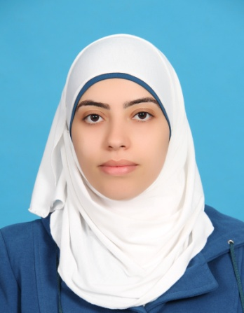
CURRICULUM VITAE
Personal Information:
- Name: Raneen Samer Sa'di Qaradeh.
- Address: Al-Makhfeyeh St , Nablus, West Bank.
- Telephone: 09-2349640
- Cell Phone: 00972599116300
- Email: raneen_qara@hotmail.com
- Date of Birth: March, 26, 1989
- Place of Birth: Palestine
- Nationality: Palestinian
- Sex: Female
Education :
- 2013-2014: MA Creative Writing (Merit), College of Arts, University of Lincoln, Lincolnshire, England.

- 2007-2011: BSc, English Literature and Language (average 88.6%), Faculty of Arts, An-Najah National University, Nablus, West Bank, email: info@najah.edu.

- 2006-2007: General Examination Board ,social sciences (average 97.6 %), Sameer sa'd Al-dean School, Nablus, West Bank.

Employment History:
- Sept. 2014 _ up to now: The English Dept., An-Najah National University, Nablus, as an English instructor.
- Oct. 2011 _ Sept. 2013 : Schools of UNRWA in Nablus and Jenin,
as an English teacher for 4th, 5th, 6th, 7th, 8th, and 9th grades.

- Feb. 2012 _ April 2012: Future Generation Hands Association, Nablus_Palestine, as a translator.
- Sept. – Oct. 2011: The Ministry of Education,Tell High school , Nablus_ Palestine , as an English teacher for the 8th and 9th grades.

- July – Sept. 2011: AMRA Information Technology Centre, Nablus _Palestine , as an English trainer for a conversation course.

Skills:
- Computer: Microsoft office (very good), Photo Paint (good) .
- Drawing and painting
- Leadership, elocution and Interviewing
- Ability to work in teams and under pressures

Professional Qualifications (Training)

- April 2013: Attended multiple workshops and lectures in IATEFL (International Association of Teachers of English as a Foreign Language), Liverpool, England.

- Sept –Oct. 2010: Attended "Creative Writing" Workshop run by the British-Syrian writer- Robin Qassab, at An-Najah National University, Nablus, West Bank.

- June 2008: Attended an “English Conversation Course", Continuing Education Center ,An- Najah National University , Nablus ,West Bank, Tel: 09239496 , email:cec@najah.edu

Other Achievements:
- Feb. 2014: Recited and talked about some of my English poems in the Cultural Diversity Festival- University of Lincoln- England, as I was nominated from the English Language Centre.

- August 2013: Conducted a workshop for English teachers of UNRWA in Nablus titled “English for Young Learners and Teenagers”. This workshop was the outcome of attending and participating in IATEFL.

- April 2013: Delivered a poster presentation in IATEFL in Liverpool-England, titled “Teaching English within Literature” where I discussed some methods of teaching English for second language learners through reading literature.

- 2010 and 2011: Supervised and conducted two English graduation ceremonies of the English Dept. at An- Najah University.

- 2010 : volunteered to teach English for male-students in PSD , Nablus , West Bank.

Languages:
Arabic : mother tongue
English : (my field of study)

Interests:
Reading, writing, painting, drawing, cooking, designing and traveling.

References:
- Dr. Fayez Aql , English Department, An-Najah National University, Nablus, West Bank, Tel: 0599168161, e-mail : faqel@yahoo.com
- Dr. Abdl Kareem Ighbareyah, An-najah National University, Nablus, West Bank, Tel: 0549784620, e-mail: kareem1@netvision.net.il
- Dr. Abdl Kareem Daraghmeh An-najah National University, Nablus, West Bank, Tel: 0599270597, e-mail: adaragmeh@najah.edu

