An-Najah National University Faculty of Engineering
Nablus Dept. of Civil Eng.
CE-460 TRANSPORTATION SYSTEMS ENGINEERING II
2nd Midterm Exam
Prof. Sameer Abu-Eisheh Duration: 1:15 hours
Dr. Khaled Al-Sahili April 16, 2009
Student Name: ____________________________ Section:_____________________

PART I – Closed Book (38 POINTS) – 25 minutes

Q1. (8 points) Define the followings:
a. Signal Phase vs. Interval

b. Eight-Hour Vehicular Volume and Four-Hour Vehicular Volume Signal Warrants

Q2. (10 points) Choose the most appropriate answer for the followings:
- One of the followings occurs at maximum density (jam density)
(a) u_{s} = q = 0 (b) Free-flow speed (c) q = q_{max}/2 (d) u_{s} = u_{f}/2
2. One of the following describes the characteristic of neighborhood traffic circle:
(a) Circle diameters are small (b) Parking is not allowed at the circle
(c) Must use yield sign on all approaches (d) All of the above
3. One of the design principles for at-grade intersection is "profile." This includes:
(a) Grades must not exceed 7% (b) Preferred maximum grade is 3%
(c) Angle of intersection should almost be perpendicular (d) All of the above
4. Based on AASHTO procedures, the turning radius at intersections depends on:
(a) Design speed (b) Super-elevation
(c) Design vehicle (d) All of the above
5. The purpose of traffic control is to
(a) Assign the right of way to drivers (b) Minimize delay
(c) Control speed (d) All of the above
6. Refuge Islands are:
(a) Used to alert drives that they are approaching an intersection
(b) Used to eliminate confusion to motorists at intersections with different movements
(c) Formed by a combination of raised islands and pavement marking
(d) Used mainly for pedestrians crossing wide intersections.
7. The Multi-Way Stop Signs are used:
(a) When traffic volume on the major street is high
(b) Traffic volume on all approaches are approximately equal
(c) When signal warrants are not justified
(d) All of the above

Q3. (10 points) Traffic on a major street in a city of Tulkarm was observed, and it was concluded that Greenshield Model fairly represents this flow. The capacity of this street was measured to be 2800 veh/hr, and traffic comes to a complete halt (stop) at a density of 100 veh/hr. Draw a flow-density-speed curves showing key values on these curves.

Q4. (10 points) For the following intersection, draw all possible types of conflict points and show their numbers.

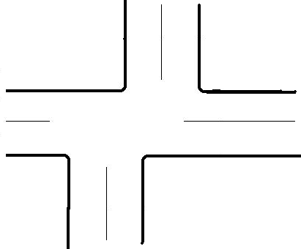

An-Najah National University Faculty of Engineering
Nablus Dept. of Civil Eng.
CE-460 TRANSPORTATION SYSTEMS ENGINEERING II
2nd Midterm Exam
Prof. Sameer Abu-Eisheh Duration: 1:15 hours
Dr. Khaled Al-Sahili April 16, 2009
Student Name: ____________________________ Section:_____________________

PART II – Open Book (62 POINTS) – 45 minutes

Q5. (10 points) For the intersection shown below, what are the minimum required turning radiuses using a simple circular curve? The design vehicle is "Single Unit trucks" and design hourly volume is shown below.

